**Daily Scrum or Standup Meeting**

Team name: Team 08

Scrum Master: Hannah Howell

Date: Oct 16

|  |  |  |  |
| --- | --- | --- | --- |
| **Team Member** | **What did you do since the last scrum?** | **What do you plan to do before the next scrum?** | **What obstacles do you have?** |
| Hannah Howell | Pulled the project Zion created, reviewed the documents within. | Review Django tutorials, get project running | N/A |
| Garrett Johnson | Watched Django tutorials | Get Django re-installed, update python so we’re all on same version | N/A |
| Zion Steiner | Created Django project, started tutorial for unit testing | Finish Django tutorial, get through Vue tutorial | N/A |
| Tristan Thomas | ** Out sick for the day ** |  |  |
| N/A |  |  |  |

# Burndown

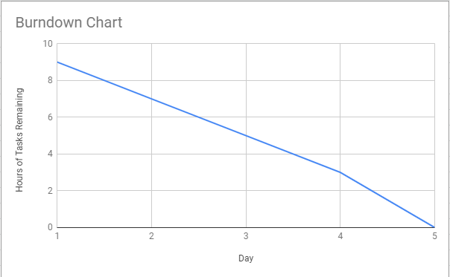

# Screenshot of you project board

